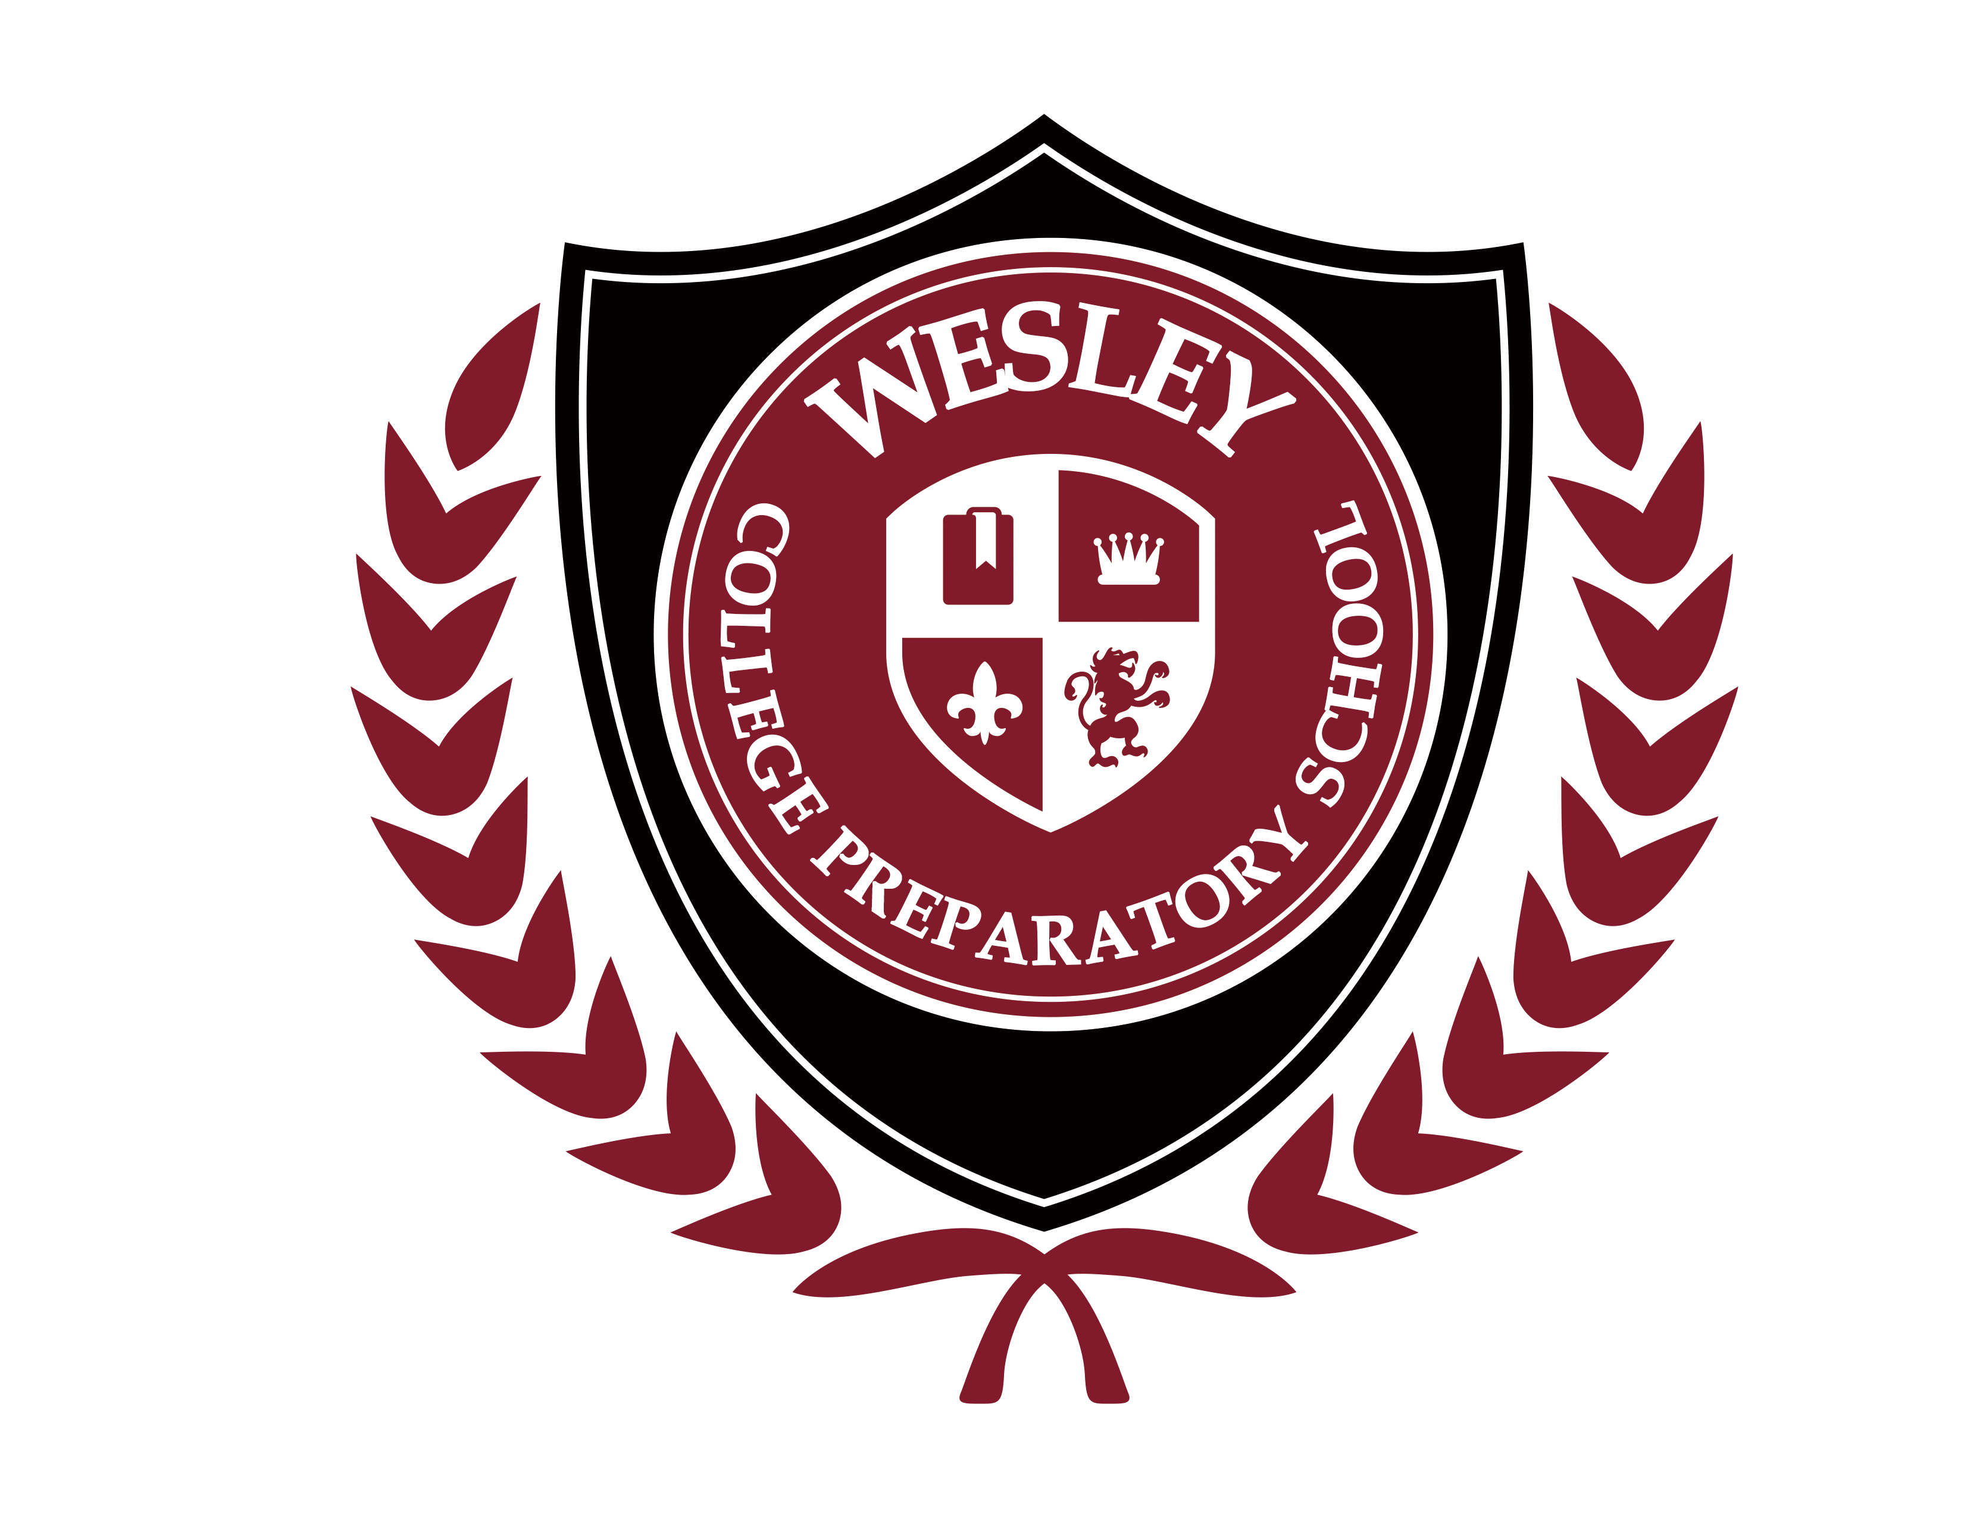
MEDIA CONSENT FORM

I, ______________________________________ grant permission to Wesley College Preparatory School (WCPS), to use my child’s ___________________________________ image (photograph and/or video) for use in Media publications for the school including:
□ Videos □ Email Blasts □ Recruiting Brochures
- Websites and/or Affiliates □ General Publications □ Newsletters
- Magazines □ Yearbooks □ Flyers

Please initial the paragraph below which is applicable to your present situation:
_____ I am the parent or legal guardian of the above-named child. I have read this release before signing below, and I fully understand the contents, meaning and impact of this release.
_____ I am 20 years of age or older and I am competent to contract in my own name. I have read this release before signing below, and I fully understand the contents, meaning and impact of this release.

Signature of Student: ______________________________ Date: ___________________

Name of Student: _________________________________

Signature of Parent/Guardian: _______________________ Date: ___________________
(must sign if child is under 20 years of age)

